6.78: The work done by gravity is 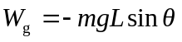 (negative since the cat is moving up), and the work done by the applied force is FL, where F is the magnitude of the applied force. The total work is
The cat’s initial kinetic energy is 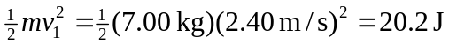, and
